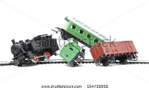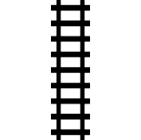

**Allied Table Edge**

**Axis Table Edge**

The blue arrows indicate the entry points for Axis reinforcements. D 6 roll determines which point entry is made

**Derailed Train**